*The Great Houses*

Proposal for the HCC2 Web Development Project

*Submitted by Jamie Mulvaney x12358831*

# *Introduction*

*My project will be on the domain of the great houses from the book series a song of fire and ice and the TV show a game of thrones. I choose this because it will give me a rich amount of information to draw from when writing my xml document. It will also give me a lot of freedom when it comes to design of the webpages themselves. Another reason I choose this project is because I know a lot about the area and the differences between both the books and the TV show.*

# *Goals*

*The main goal of this project is to use the netbean’s software to develop a web application that will display an xml document written on my chosen subject matter.*

* *Display the great house’s using xml and xslt*
* *Use Fireworks and other tools to design the look and feel of some of my webpages*
* *Use jqeury to display images and allow the user to interact with the webpages*
* *Use inline styling to div’s and other parts of the webpages.*
* *Have multiple xslt opening using java servlets*
* *Have dtd’s and xml schema’s for all xml documents*
* *Have working jquerys such as hovers and slide’s.*

# *Strategy*

*The Strategy I will employ,*

*The xml and xslt will be written in week 6*

*The web application will begin to be written in week 7 I will also design the opening html page during this week.*

*Week 8 I will be begin developing the xslt pages and servlets these will be a base model with no images or design just test pages to see if the information is being called and can be viewed.*

*Week 9 I will begin using Adobe Fireworks to begin the image styling and buttons to display the information on the webpages.*

*Week 10 I will be importing the images and style designs made in week 9 the give the webpages a better feel and design.*

*Week 11 I will be adding samples of jqeury to give the website more of an interactive feel for the user.*

*Week 12 finish up and write the report*

# Functionality

*The functionality that will be available,*

* *There will be jqeury drop down images that will display a lot of information.*
* *You will be able to few what houses you want from the homepage be clicking on the house sigils.*
* *There will be a login forum and a review page for the users to use*
* *The will be a page that gives you the latest event that has happen in game of thrones*
* *There will be ajax so the user can preview there information*
* *There will be jqeury hovers to display images of chosen events and people*

*The people who will be using my project will be people looking for information on the chosen subject and wants a dynamitic feel and design.*

*You can view stills of the sites below,*

*Enter Page*

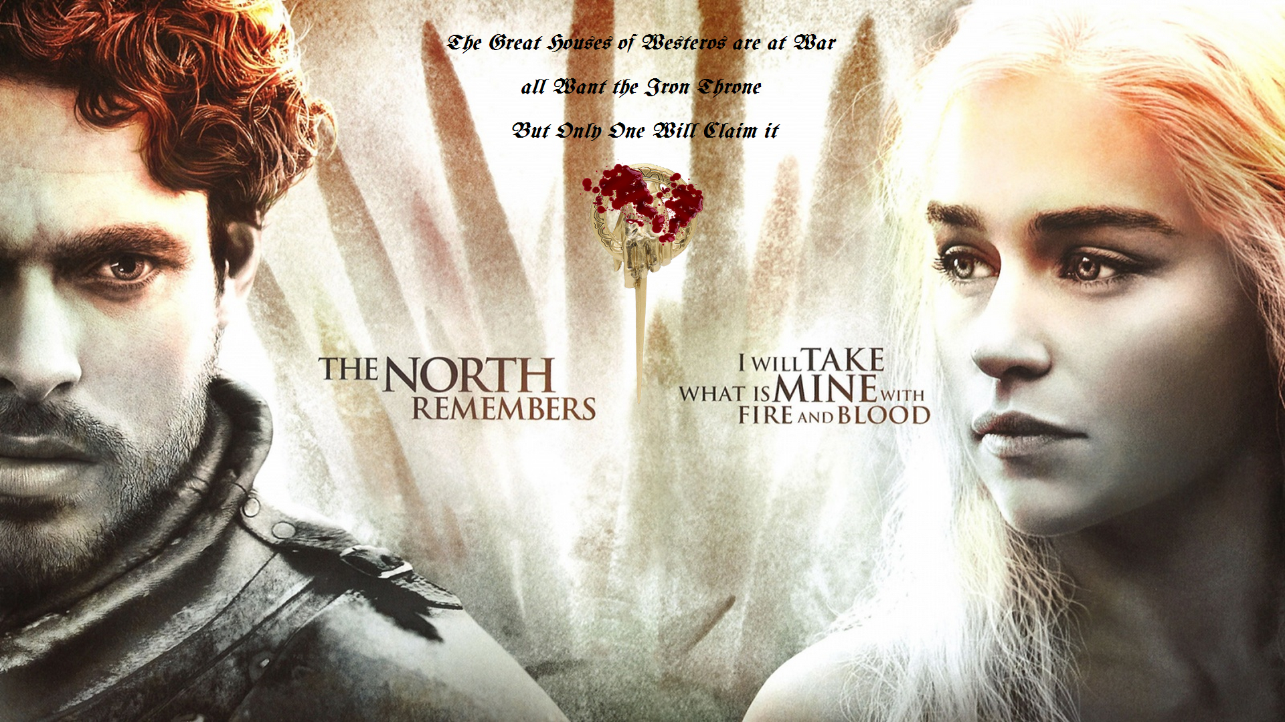

*Main Home Page*

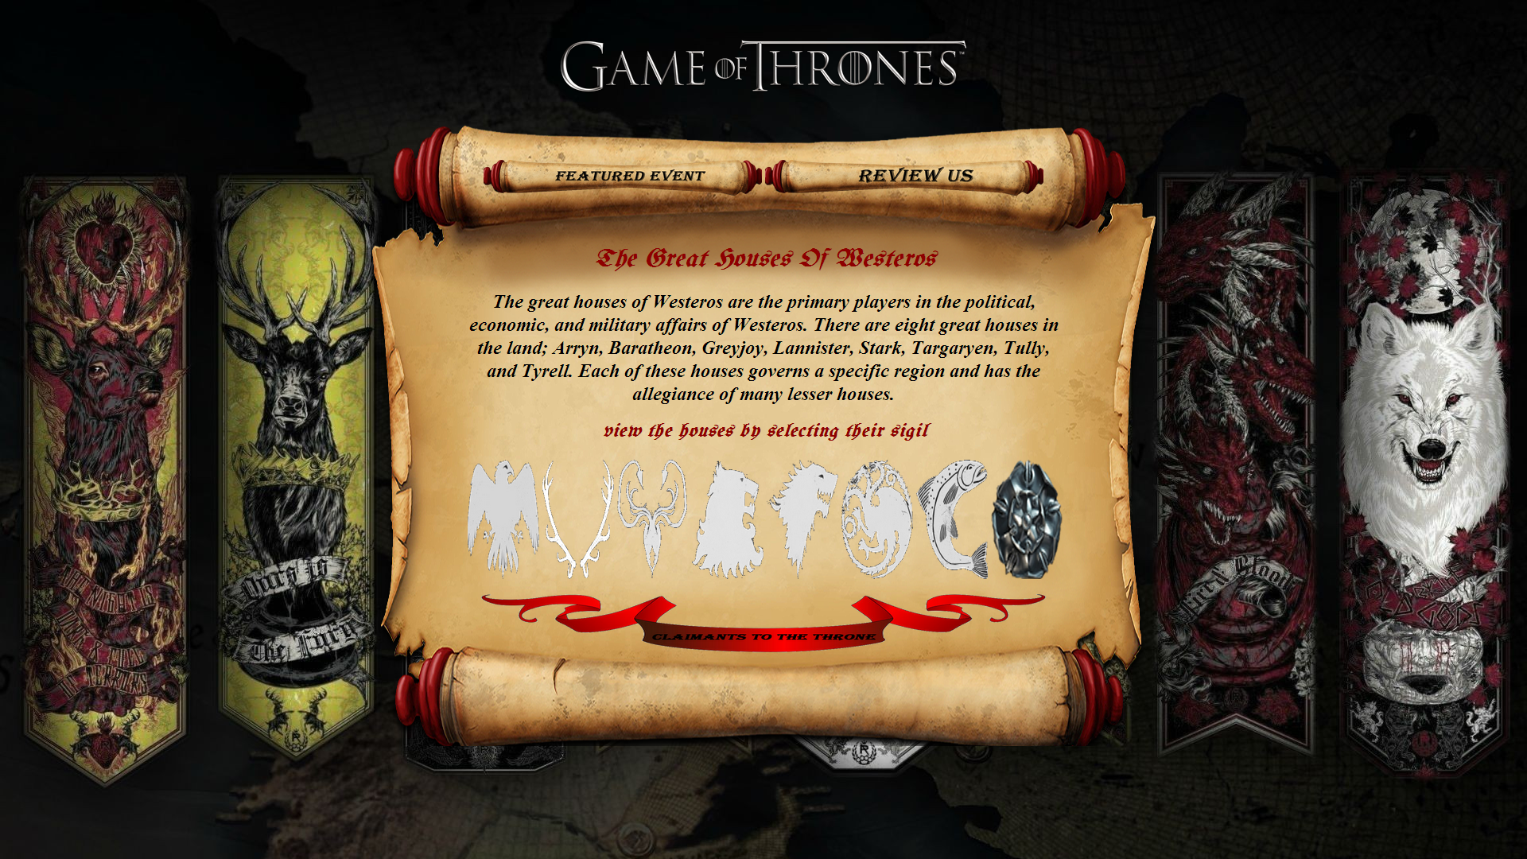

*A Sample of the Houses Page*

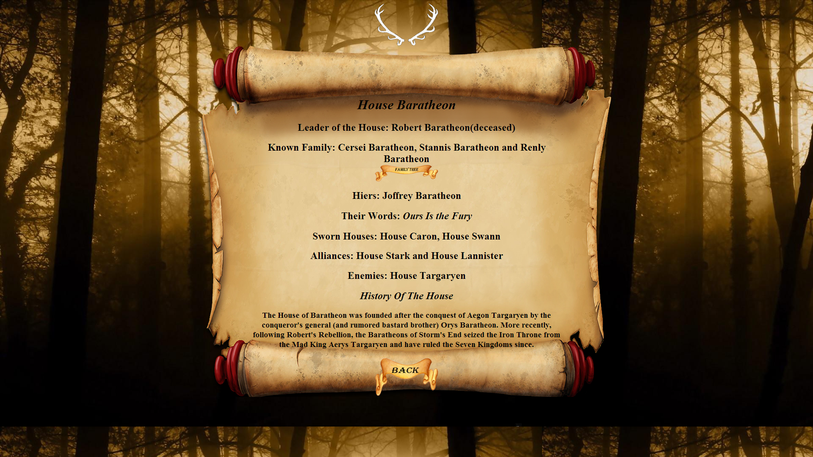

*A Sample of the houses page with the jqeury drop down*

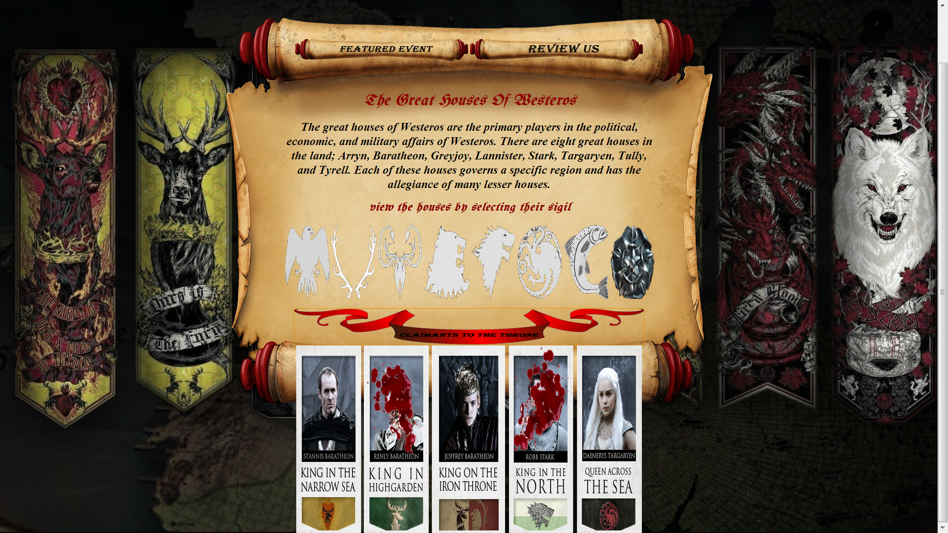

A sample of jquery hovers

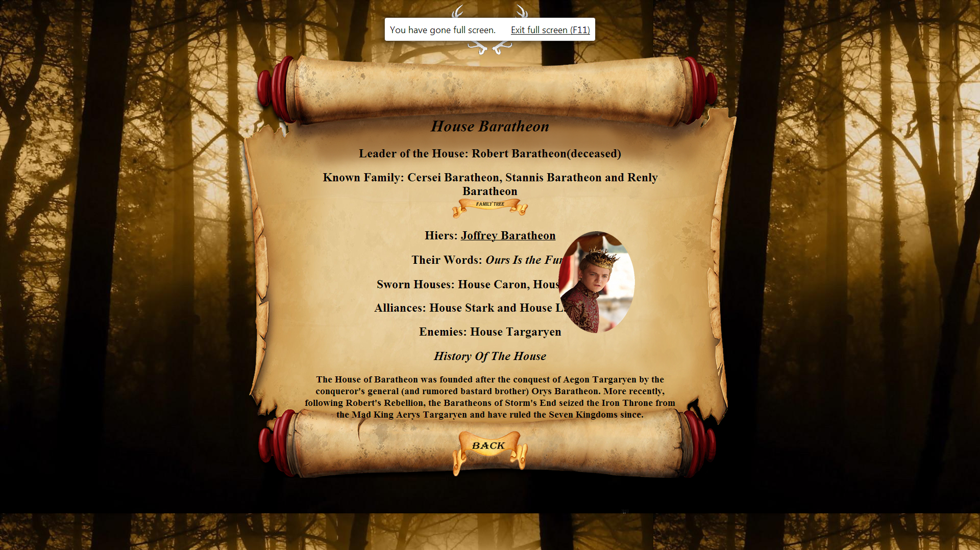

Login Form

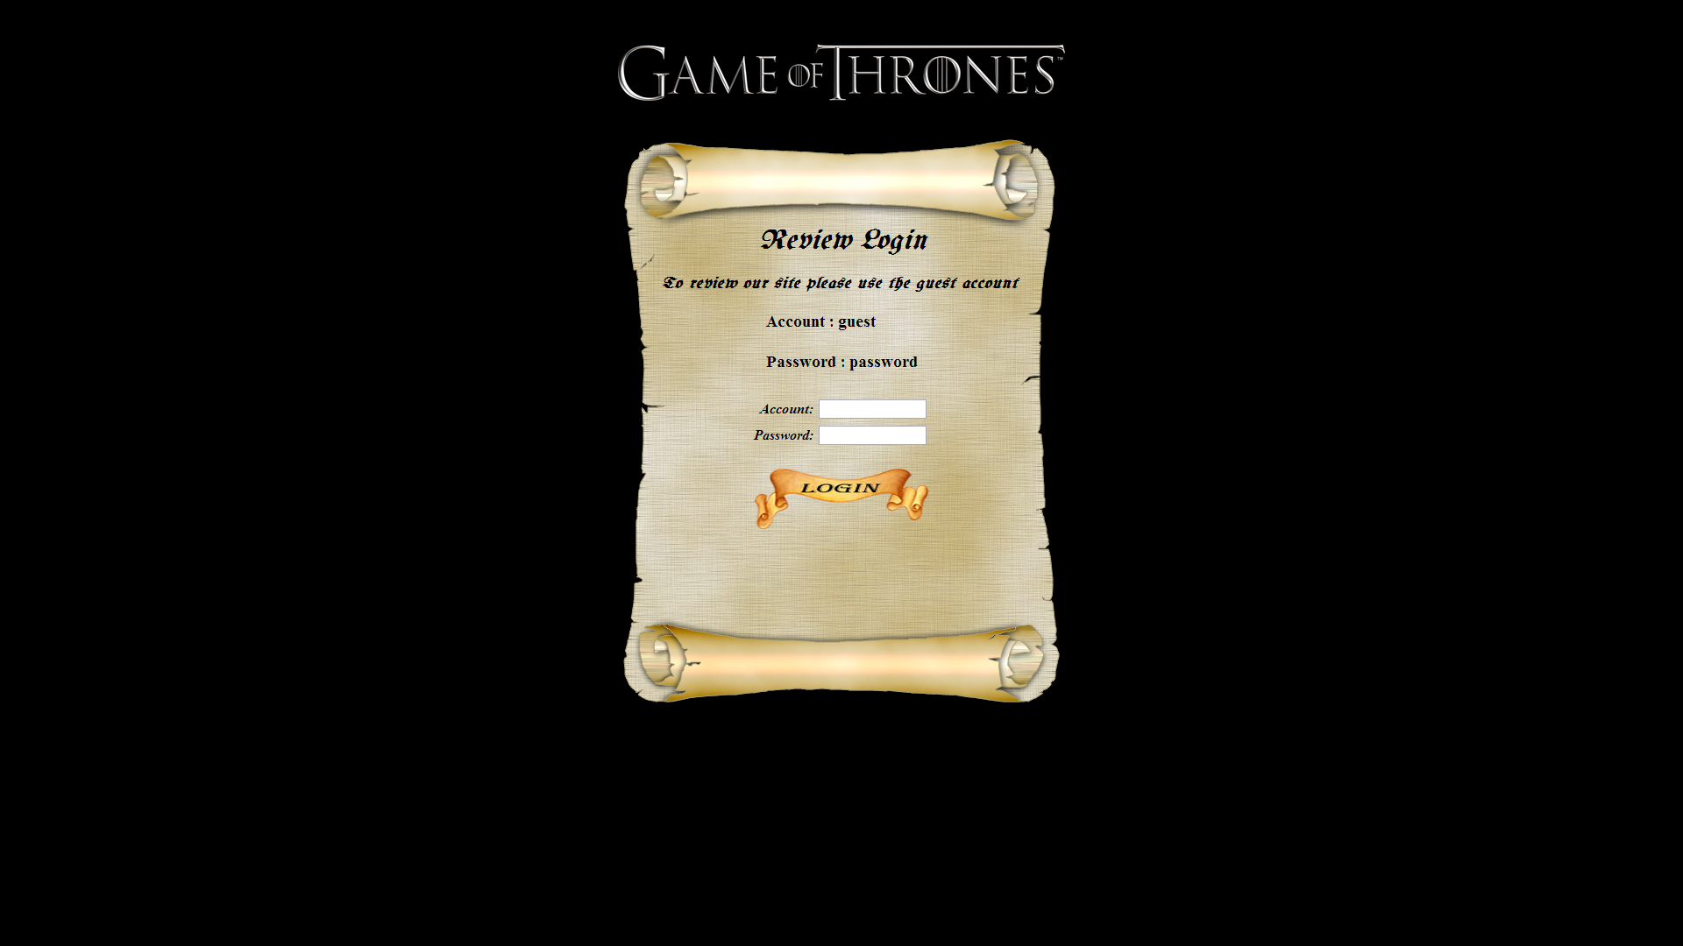

The review page with ajax and email validator

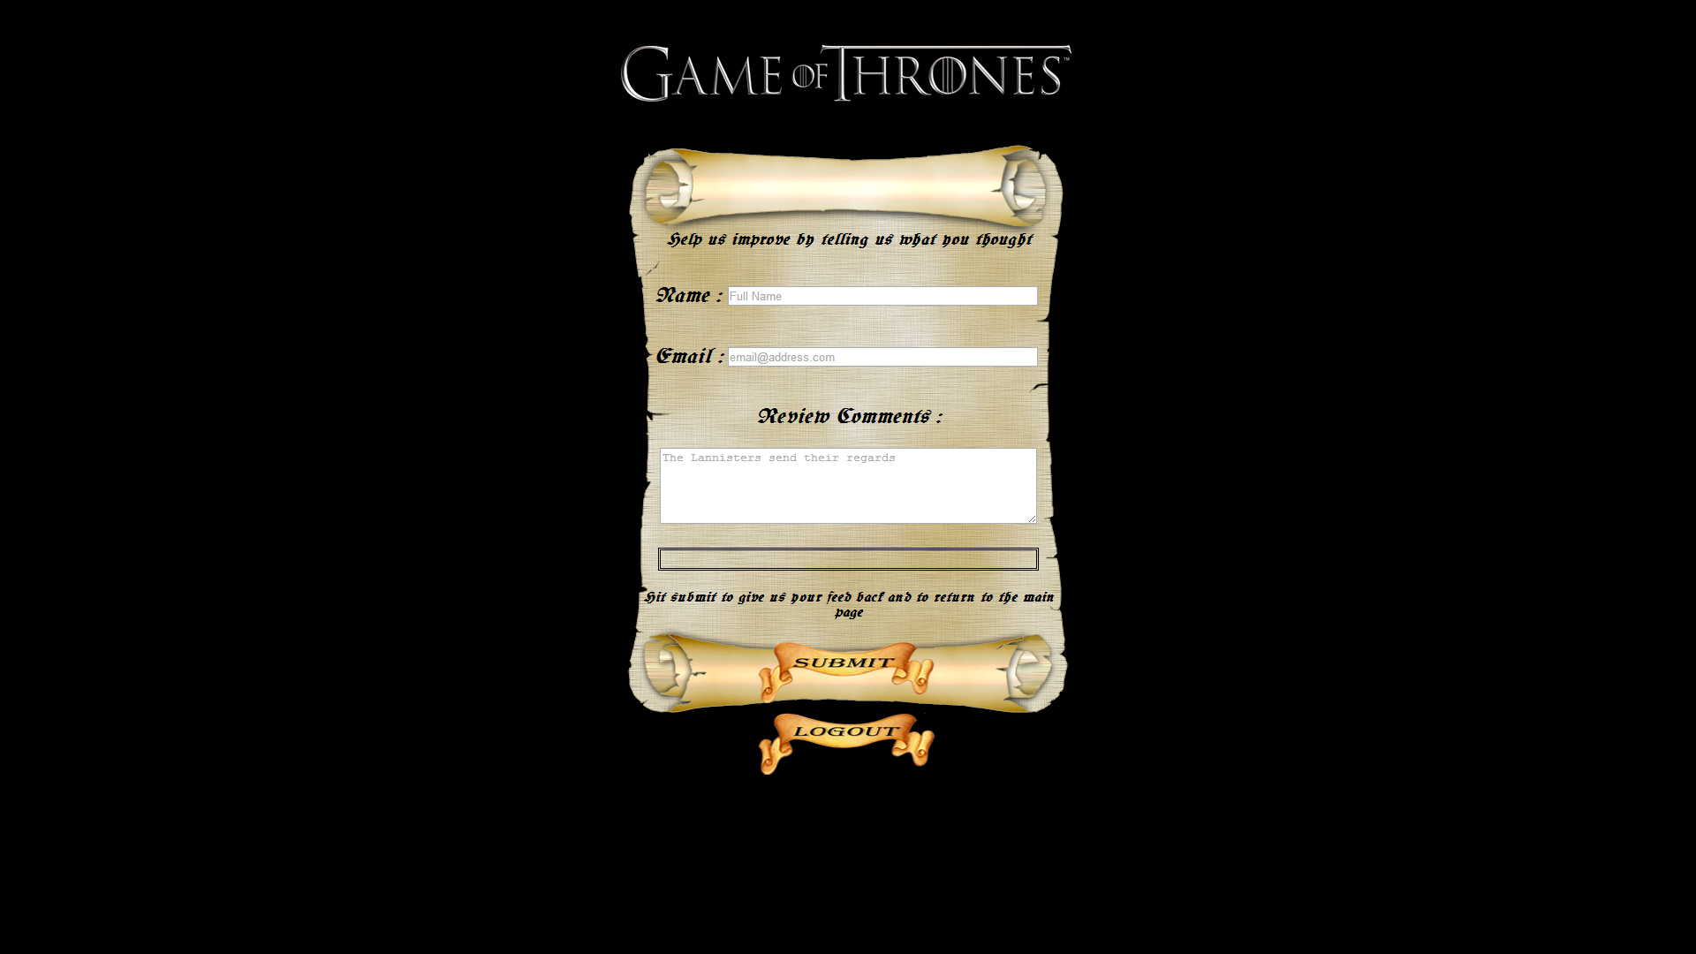

# Deliverables

* *An xml file with 5 nested levels*
* *More than one xslt page*
* *A web app that holds and displays all the information we need.*
* *Use of ajax and jquery to design the web page*
* *Login form*
* *Must be built in netbean’s*
* *Using hovers to display images*
* *Add valid xml schemas and DTD’s for the xml’s*
* *Have all pages validated*
* *Use ajax on the review page forum*
* *Have a login system*